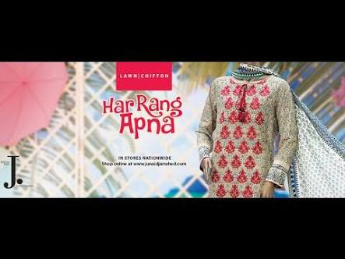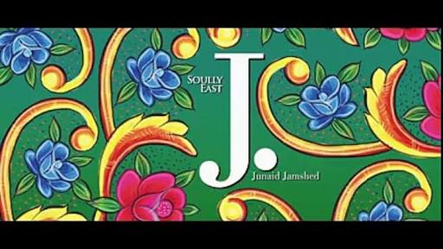**KARACHI:**Taking a leaf out of the book of Pakistani truck artists, J. unveiled their latest offering, Volume I: Har Rang Apna on Thursday evening.

CONTACT NO:9876543210

EMAIL:pricess.xyz987@gmail.com

ADDRESS: N.Nazimabad karachi